- This is a Sample Project to help you understand the concept of work in HCL Solution Pvt. Ltd.
- You are required to type the exact text from the left box to the blank box at the right.
- The size of the text should be 8-10 and theme should be ‘Arial’ or ‘Times New Roman’.
- The main project would contain further information regarding submission of assignment.
- This Project Work Will be Provide in Diamond Plan Only.
with the scientific method and you would have given
them their historic mission: Explore this place and find
out how it work and what it means that we find our-
selves alive here.
‘ You knew you had lost your certainty about a God-
ruled universe and, because of that, your certainty about
the nature of God himself. But you felt you had a method,
a consensus-building process through which you could
discover the nature of everything around you, including
God, and including the true purpose of mankind’s
existence on the planet. So you sent these explorers out to
find the true nature of your situation and to report back.’
He paused and looked at me.
‘’The Manuscript,’ he said, ‘says that at this point we
began the preoccupation from which we are awakening
now. We sent these explorers out to bring back a complete
explanation of our existence, but because of the
complexity of the universe they weren’t able to return
right away.’
‘What was the preoccupation?’
‘Put yourself in that time period again, ‘ he said. ‘When
the scientific method couldn’t bring back a new picture of
certainty and meaning affected western culture deeply.
We needed something else to do until or questions were
answered. Eventually we arrived at what seemed to be a
very logical solution. We looked at each other and said:
‘’Well, since our explorers have not yet returned with our
true spiritual situation, why not settle into this new
world of ours while we are waiting? We are certainly
learning enough to manipulate this new world for our
own benefit, so why not wok in the meantime to raise
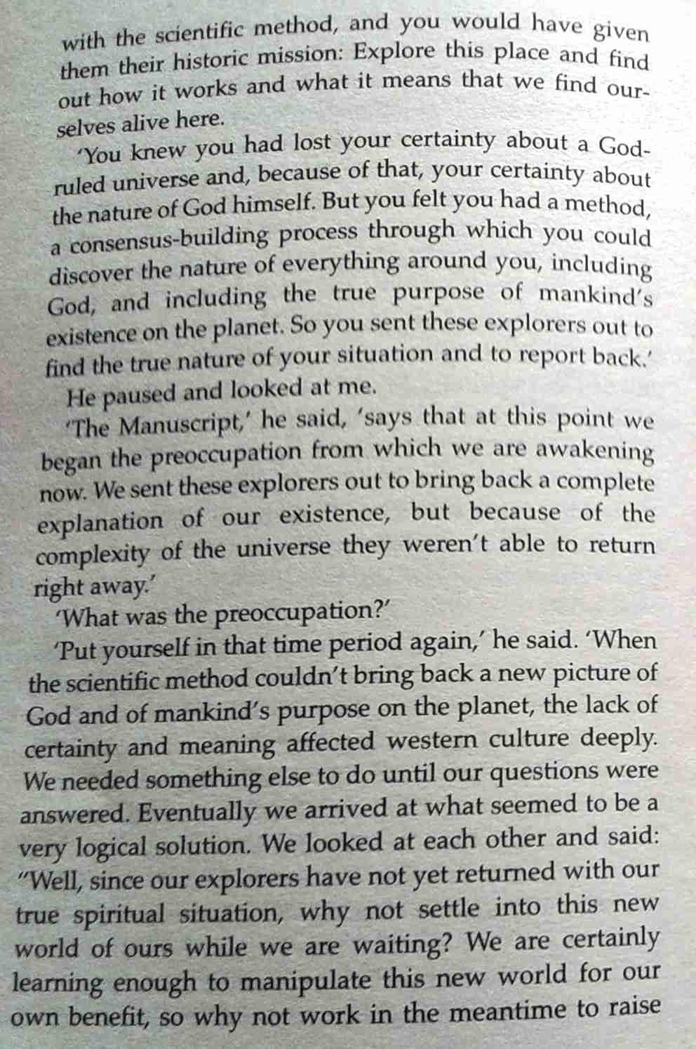
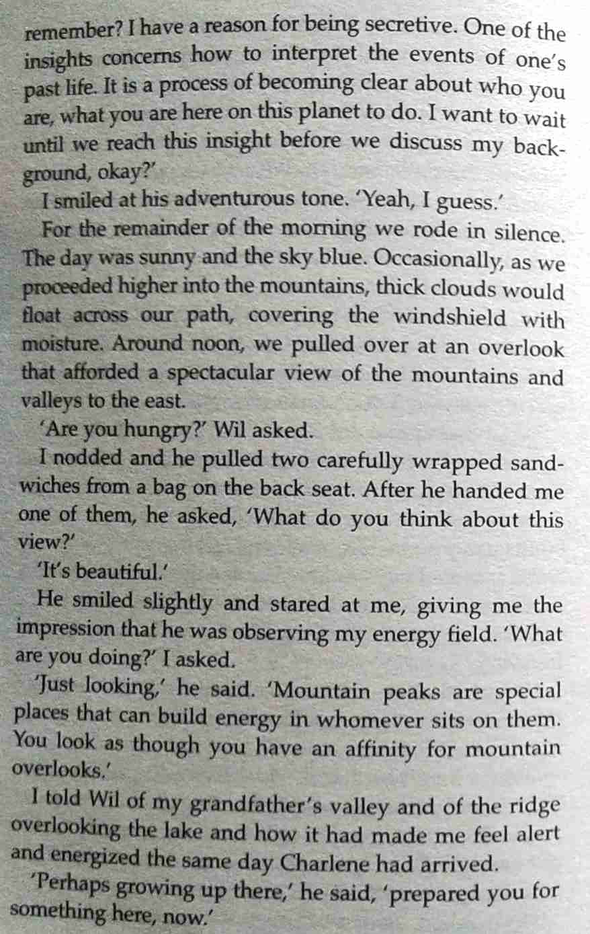
Remember? I have a reason for being secretive. One of the insights concerns how to interpret the events of one’s
past life. It is a process of becoming clear about who you
are, what you are here on this planet to do. I want to wait
until we reach this insight before we discuss my back-
ground, okay?’

else.’ He shot me a smile. ‘We can meet back here.’
The thought came to me to tell him about Robert
Jensen but I decided against it.
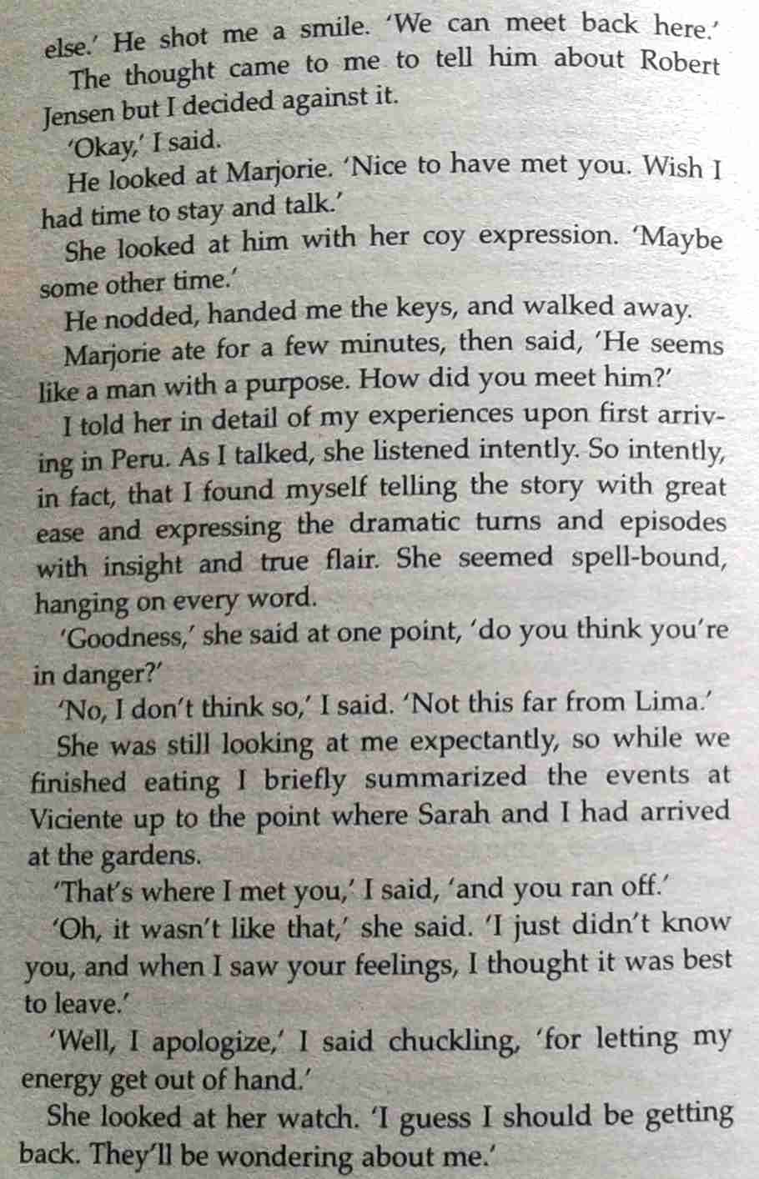

sound and movement, I decided to walk through the
woods beside it, angling back into the valley. My body
felt heavy again. What had I been doing, I asked myself.
Why had I been walking in the road? I must have been
crazy, deluded by the shock of the shooting, entranced in
some state of euphoria. Get real, I told myself. You have
to be careful. There are people here who will kill you if
You make this slightest mistake!
